|  |  |  |
| --- | --- | --- |
| TAU | FYS-1287 PHYSICS III | 14.01.2019 |
|  | DC circuit measurements | Sijan Pandey 293831  Jetro Sihvonen 291986 |

CONTENTS

[**1** **Introduction 1**](https://word-edit.officeapps.live.com/we/wordeditorframe.aspx?ui=fi-FI&rs=fi-FI&hid=mKKcux7IFE24hmswWZP2fw.0&wopisrc=https%3A%2F%2Fwopi.onedrive.com%2Fwopi%2Ffiles%2F7654DF9BA881968F!6402&wdnewandopenct=1578849231482&wdprevioussession=fdc82047-95af-4267-90e3-1e4b9f9214cc&wdorigin=OFFICECOM-WEB.START.NEW&wde=docx&sc=host%3D%26qt%3DFolders&mscc=1&wdp=0&uih=OneDrive&jsapi=1&newsession=1&corrid=8ee93df6-badb-4737-bdb1-0bfab9097f0c&usid=8ee93df6-badb-4737-bdb1-0bfab9097f0c&instantedit=1&wopicomplete=1&wdredirectionreason=Unified_SingleFlush#_Toc467656836)

[**2** **Theoretical background 1**](https://word-edit.officeapps.live.com/we/wordeditorframe.aspx?ui=fi-FI&rs=fi-FI&hid=mKKcux7IFE24hmswWZP2fw.0&wopisrc=https%3A%2F%2Fwopi.onedrive.com%2Fwopi%2Ffiles%2F7654DF9BA881968F!6402&wdnewandopenct=1578849231482&wdprevioussession=fdc82047-95af-4267-90e3-1e4b9f9214cc&wdorigin=OFFICECOM-WEB.START.NEW&wde=docx&sc=host%3D%26qt%3DFolders&mscc=1&wdp=0&uih=OneDrive&jsapi=1&newsession=1&corrid=8ee93df6-badb-4737-bdb1-0bfab9097f0c&usid=8ee93df6-badb-4737-bdb1-0bfab9097f0c&instantedit=1&wopicomplete=1&wdredirectionreason=Unified_SingleFlush#_Toc467656837)

[**3** **Laboratory measurements 1**](https://word-edit.officeapps.live.com/we/wordeditorframe.aspx?ui=fi-FI&rs=fi-FI&hid=mKKcux7IFE24hmswWZP2fw.0&wopisrc=https%3A%2F%2Fwopi.onedrive.com%2Fwopi%2Ffiles%2F7654DF9BA881968F!6402&wdnewandopenct=1578849231482&wdprevioussession=fdc82047-95af-4267-90e3-1e4b9f9214cc&wdorigin=OFFICECOM-WEB.START.NEW&wde=docx&sc=host%3D%26qt%3DFolders&mscc=1&wdp=0&uih=OneDrive&jsapi=1&newsession=1&corrid=8ee93df6-badb-4737-bdb1-0bfab9097f0c&usid=8ee93df6-badb-4737-bdb1-0bfab9097f0c&instantedit=1&wopicomplete=1&wdredirectionreason=Unified_SingleFlush#_Toc467656839)

[**4** **Measurement results and observations 2**](https://word-edit.officeapps.live.com/we/wordeditorframe.aspx?ui=fi-FI&rs=fi-FI&hid=mKKcux7IFE24hmswWZP2fw.0&wopisrc=https%3A%2F%2Fwopi.onedrive.com%2Fwopi%2Ffiles%2F7654DF9BA881968F!6402&wdnewandopenct=1578849231482&wdprevioussession=fdc82047-95af-4267-90e3-1e4b9f9214cc&wdorigin=OFFICECOM-WEB.START.NEW&wde=docx&sc=host%3D%26qt%3DFolders&mscc=1&wdp=0&uih=OneDrive&jsapi=1&newsession=1&corrid=8ee93df6-badb-4737-bdb1-0bfab9097f0c&usid=8ee93df6-badb-4737-bdb1-0bfab9097f0c&instantedit=1&wopicomplete=1&wdredirectionreason=Unified_SingleFlush#_Toc467656840)

[**5** **Result calculation 3**](https://word-edit.officeapps.live.com/we/wordeditorframe.aspx?ui=fi-FI&rs=fi-FI&hid=mKKcux7IFE24hmswWZP2fw.0&wopisrc=https%3A%2F%2Fwopi.onedrive.com%2Fwopi%2Ffiles%2F7654DF9BA881968F!6402&wdnewandopenct=1578849231482&wdprevioussession=fdc82047-95af-4267-90e3-1e4b9f9214cc&wdorigin=OFFICECOM-WEB.START.NEW&wde=docx&sc=host%3D%26qt%3DFolders&mscc=1&wdp=0&uih=OneDrive&jsapi=1&newsession=1&corrid=8ee93df6-badb-4737-bdb1-0bfab9097f0c&usid=8ee93df6-badb-4737-bdb1-0bfab9097f0c&instantedit=1&wopicomplete=1&wdredirectionreason=Unified_SingleFlush#_Toc467656841)

[**6** **Error analysis 3**](https://word-edit.officeapps.live.com/we/wordeditorframe.aspx?ui=fi-FI&rs=fi-FI&hid=mKKcux7IFE24hmswWZP2fw.0&wopisrc=https%3A%2F%2Fwopi.onedrive.com%2Fwopi%2Ffiles%2F7654DF9BA881968F!6402&wdnewandopenct=1578849231482&wdprevioussession=fdc82047-95af-4267-90e3-1e4b9f9214cc&wdorigin=OFFICECOM-WEB.START.NEW&wde=docx&sc=host%3D%26qt%3DFolders&mscc=1&wdp=0&uih=OneDrive&jsapi=1&newsession=1&corrid=8ee93df6-badb-4737-bdb1-0bfab9097f0c&usid=8ee93df6-badb-4737-bdb1-0bfab9097f0c&instantedit=1&wopicomplete=1&wdredirectionreason=Unified_SingleFlush#_Toc467656842)

[**7** **Conclusion 3**](https://word-edit.officeapps.live.com/we/wordeditorframe.aspx?ui=fi-FI&rs=fi-FI&hid=mKKcux7IFE24hmswWZP2fw.0&wopisrc=https%3A%2F%2Fwopi.onedrive.com%2Fwopi%2Ffiles%2F7654DF9BA881968F!6402&wdnewandopenct=1578849231482&wdprevioussession=fdc82047-95af-4267-90e3-1e4b9f9214cc&wdorigin=OFFICECOM-WEB.START.NEW&wde=docx&sc=host%3D%26qt%3DFolders&mscc=1&wdp=0&uih=OneDrive&jsapi=1&newsession=1&corrid=8ee93df6-badb-4737-bdb1-0bfab9097f0c&usid=8ee93df6-badb-4737-bdb1-0bfab9097f0c&instantedit=1&wopicomplete=1&wdredirectionreason=Unified_SingleFlush#_Toc467656843)

[**8** **References 4**](https://word-edit.officeapps.live.com/we/wordeditorframe.aspx?ui=fi-FI&rs=fi-FI&hid=mKKcux7IFE24hmswWZP2fw.0&wopisrc=https%3A%2F%2Fwopi.onedrive.com%2Fwopi%2Ffiles%2F7654DF9BA881968F!6402&wdnewandopenct=1578849231482&wdprevioussession=fdc82047-95af-4267-90e3-1e4b9f9214cc&wdorigin=OFFICECOM-WEB.START.NEW&wde=docx&sc=host%3D%26qt%3DFolders&mscc=1&wdp=0&uih=OneDrive&jsapi=1&newsession=1&corrid=8ee93df6-badb-4737-bdb1-0bfab9097f0c&usid=8ee93df6-badb-4737-bdb1-0bfab9097f0c&instantedit=1&wopicomplete=1&wdredirectionreason=Unified_SingleFlush#_Toc467656844)

[**9** **Attachments 4**](https://word-edit.officeapps.live.com/we/wordeditorframe.aspx?ui=fi-FI&rs=fi-FI&hid=mKKcux7IFE24hmswWZP2fw.0&wopisrc=https%3A%2F%2Fwopi.onedrive.com%2Fwopi%2Ffiles%2F7654DF9BA881968F!6402&wdnewandopenct=1578849231482&wdprevioussession=fdc82047-95af-4267-90e3-1e4b9f9214cc&wdorigin=OFFICECOM-WEB.START.NEW&wde=docx&sc=host%3D%26qt%3DFolders&mscc=1&wdp=0&uih=OneDrive&jsapi=1&newsession=1&corrid=8ee93df6-badb-4737-bdb1-0bfab9097f0c&usid=8ee93df6-badb-4737-bdb1-0bfab9097f0c&instantedit=1&wopicomplete=1&wdredirectionreason=Unified_SingleFlush#_Toc467656845)

**1** **Introduction**

This experiment deals with the properties of voltmeter and ammeter and their use to measure electrical quantities. Methodological errors present in the experiment are also analyzed and corrected.

# **2** **Theoretical background**

Power supply, conductors and load make up an electrical circuit. Energy transformation to electrical form is done by a power supply from other forms of energy. In contrast, a load consumes the electricity supplied to it in the circuit and converts the electric energy into some other form[1].

Fig. 1

In our experiment, stabilized voltage source which transformed AC current to low voltage DC current worked as a power supply. Electromotive force(emf) influences the current in the circuit to move from lower to higher potential[2]. Voltage source tries to keep its emf *E* constant even when the current in load changes[1].

A load in a closed circuit is quantified by resistance *R*[1]. It is mathematically represented by equation (1).

(1)

Where *U* is the voltage drop across the resistor *R* and *I* is the electric current flowing through the resistor.

Power quantifies the amount of electrical energy consumed by the load in unit time[1]. It is mathematically represented by equation (2).

(2)

**2.1 Electrical measurements and devices used to measure them**

Ammeter measures electric current in a circuit and voltmeter measures voltage drop across a load. Ammeter is connected in series with load and source and voltmeter is connected in parallel with load and source in a circuit.

Fig. 2

Two types of meters can be found: digital and analog. In analog devices, quantites are measured proportional to another quantity using an angle and appropriate scale is used to point the measurement value being equal to the given angle made in the meter. In digital meter, measurements are shown in figures[1].

**2.2 Meter couplings**

To measure the current and voltage in a load simultaneously, ammeter and coltmeter can be coupled in two ways. They are short coupling and long coupling[1]. These couplings are shown in figure 3.

Fig. 3

Ammeters and voltmeters show their own current and voltage respectively between their poles. If ideal devices are used, the resistance of the load would be given by equation (1). However, meters used are not ideal. These meters have their own internal resistances and consume energy. This leads to errors in the result obtained by measuring voltage and current and plugging those values in equation (1) [1]. So, short coupling and long coupling is done to correct methodological error in the measurement.

In short coupling(shown in fig. 3(a)), voltmeter measures the voltage difference across the load but ammeter measures the current flowing in both the voltmeter and the load. According to Kirchoff’s law, the current in the ammeter is the sum of currents in voltmeter and the load[1]. The current in ammeter *I*A is given by

(3)

where *I* is current through the load and *I*V is the current through the voltmeter.

If *R*V is the voltmeter’s internal resistance, then

(4)

From equation (3) and (4), the current through the load is given by

(5)

In long coupling(shown in fig. 3(b)), ammeter shows the current through the load and voltmeter measures the sum of voltage difference across ammeter and the load which is the total voltage difference between its poles[1]. Applying Kirchoff’s voltage law,

⇒   (6)

Then, the voltage across the load is

∴ (7)

where, is the voltage difference measured by the voltmeter in long coupling, *R*A is the ammeter’s internal resistance and *I* is the current through ammeter and the load.

Equations (5) and (7) are used to correct the methodological error.

Fig. 4

**3**        **Laboratory measurements**

The measurements were conducted using a variety of devices including a power source, voltmeter, ammeter, multimeter, a lamp and some resistors. The devices used are shown in image X below.

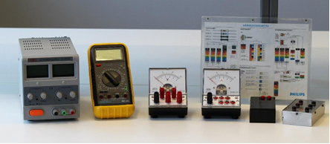

*Image X: measuring equipment [1]*

Initially the resistance of the resistors was determined using the both the multimeter and the color coding of the resistor. After this the circuit was set up as described in the theory part; first the short coupling and then the long coupling. The measuring range used for the ammeter and the voltmeter was chosen by calculating the theoretical maximum values expected for each measurement.

For each circuit long and short coupling the relationship of voltage and current was measured using the lamp and the two resistors chosen, one with a large resistance (> 5000 Ω) and the other with a low resistance (< 1000 Ω). The measurements were conducted with set voltages by adjusting the input of the power source. Five different measuring points were taken within the recommended measuring range. For each voltage the current was measured and written down.

**4**        **Measurement results and observations**

The measurements made for the resistors with both short and long couplings are given below in table 1.

*Table 1. Measured data for resistors with two different couplings***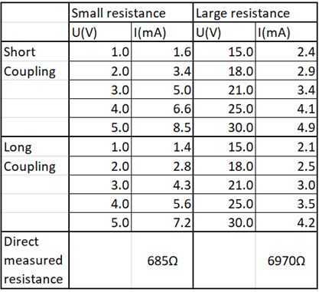**

 The measurements made on the light bulb for both the long and the short coupling are given below in table 2.

*Table 2: measured values for the light bulb*

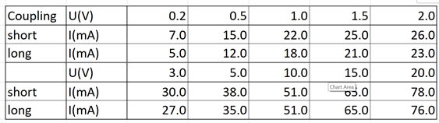

The tables shows that there is a small and expected difference between the current values for similar voltages, that is due to methodological error.

**5**        **Result calculation**

 The measured values of voltage and current for the small resistance, shown in table 1, are depicted in figure **X.**Similarly the voltage and current for the small resistance, also shown in table 1, are depicted in figure **X+1.** The current is graphed as a function of the voltage in both figures. The long and short couplings are graphed with orange and blue circles respectively. Their best fit lines are also displayed with the corresponding color. Additionally, the theoretical slope, calculated from the directly measured resistances is displayed in grey.

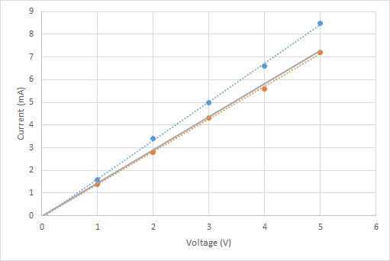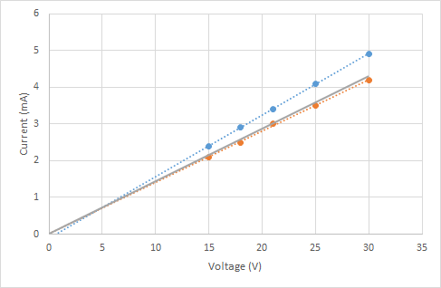

*Figure X: graph of voltage against current     Figure X+1: graph of voltage against current*

*for low resistance                                             for higher resistance*

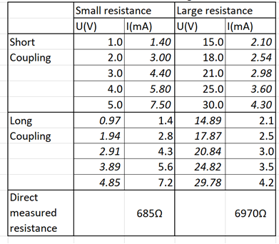

**6**        **Error analysis**

**7**        **Conclusion**

**8**        **References**

[1]

**9**        **Attachments**

Attachment 1: original log book